A picture containing clipart

Description generated with very high confidence

Azure 103 Module 4

Hands On - 10

Azure Certification Training

[**support@intellipaat.com**](mailto:support@intellipaat.com)

**+91-7022374614**

**US: 1-800-216-8930(Toll Free)**

**Azure 103 Module 4 , Hands On – 10**

**Create DNS**

**Step 1:** In Azure portal search for DNS Zones and Click on it.

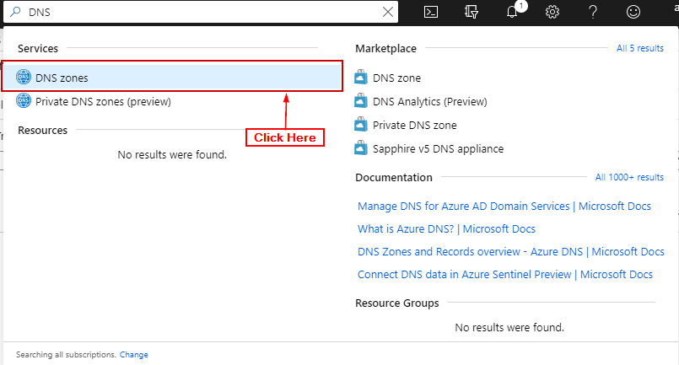

**Step 2:** Click on ‘+ Add’.

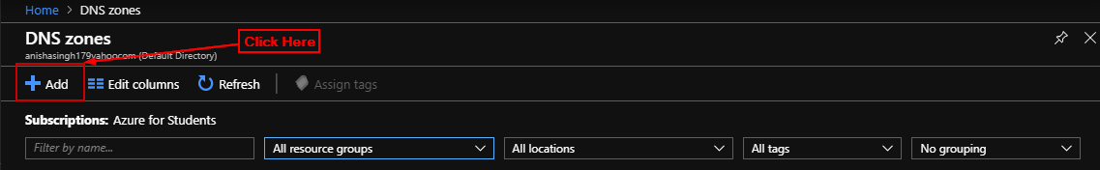

**Step 3:** Enter details and click on ‘Review + Create’.

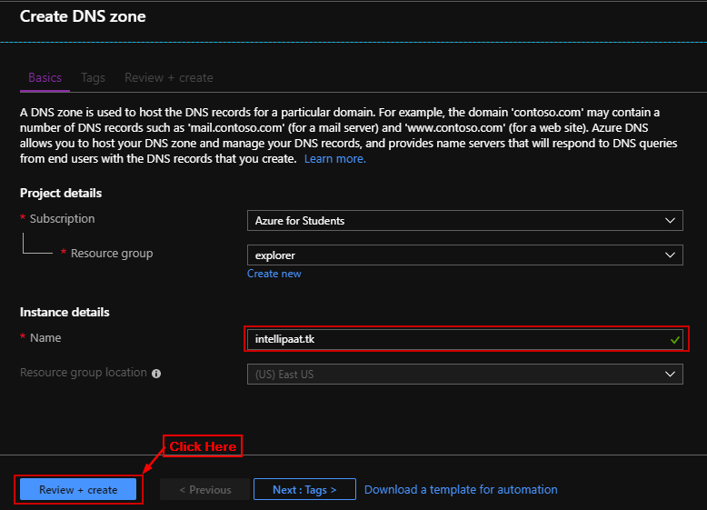

**Step 4:** Click on ‘Create’.

